**Name:** Phani Kumar

**Batch:** June 01 2022

**Tutor:** Raham Shaik

**Project Name:** Artifactory and Code.

**NEXUS ARTIFACTORY ON UBUNTU:**

1. Created an EC2 Instance with Ubuntu image and switch to root user using sudo -i – command
2. Updated the instance by using the (apt-get update -y) command
3. As a Prerequisite installed the vim package and java package
4. Installed Java Package by using ( sudo apt-get install openjdk-8-jre -y ) command



1. Went to the cd /opt directory and Fetched the Nexus download link

sudo wget <https://download.sonatype.com/nexus/3/nexus-3.39.0-01-unix.tar.gz>

from the internet.



1. Untar the nexus-3.39.0-01-unix.tar.gz file by running the ( tar -zxvf nexus-3.39.0-01-unix.tar.gz ) command



1. Rename the nexus-3.39.0-01 to nexus by running the ( mv /opt/nexus-3.39.0-01 /opt/nexus ) command.



1. Added nexus user by running the ( adduser nexus ) command.



1. Given Root Privileges to nexus user by running the ( visudo ) command.
2. Changed the ownership of the nexus by running the (chown -R nexus:nexus /opt/nexus and chown -R nexus:nexus /opt/sonatype-work ) commands.



1. Ran the vim /opt/nexus/bin/nexus.rc and nexus to run as a user.



1. To check the memory allocation ran the ( vim /opt/nexus/bin/nexus.vmoptions ) command and checked the memory allocation.
2. Replace ../sonatype-work to ./sonatype-work
3. Wrote the simple script to launch the nexus repos by running the ( vim /etc/systemd/system/nexus.service ) command.



1. Started the nexus services by running the ( systemctl daemon-reload ) command.
2. Started the nexus services by running the ( systemctl start nexus ) command.
3. Enabled the nexus service by running the ( systemctl enable nexus ) command.
4. Checked the nexus service status by running the ( systemctl status nexus ) command.





1. Taken the Public IP address and log into the web console with port 8081.
2. Successfully launched the nexus artifact.



1. Default admin user password is located in /opt/sonatype-work/nexus3/admin.password on the server.

]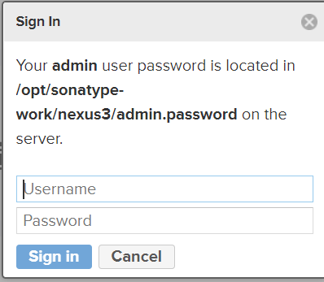

1. Accessed the Password by running the ( cat /opt/sonatype-work/nexus3/admin.password ) command.
2. To log in used admin as the username and password as the default password.
3. Changed the password immediately once login with the default password and enabled a few steps.

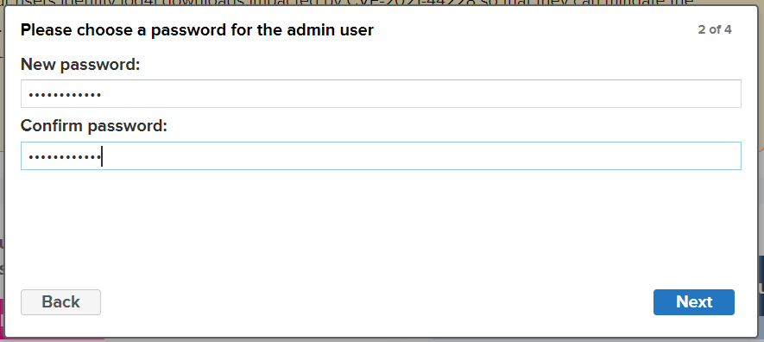

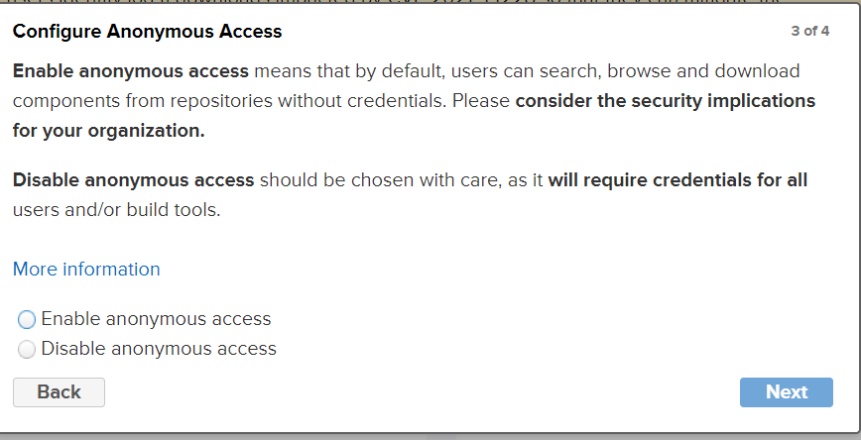

1. Successfully logged in to nexus artifact and was able to access it.

**SONARQUBE INSTALLATION ON AMAZON LINUX:**

1. Pre Requisites – Min of 2 GB ram (i.e t2 Small) – I have selected – t2.medium while creating instance
2. Installed Java 11 by running the ( amazon-linux-extras install java-openjdk11 ) command.
3. 
4. Fetched the sonarqube setup file from the internet by using the wget <https://binaries.sonarsource.com/Distribution/sonarqube/sonarqube-9.4.0.54424.zip>



1. Unzip sonarqube by using following command ( unzip - sonarqube-9.4.0.54424.zip )



1. Moved to /opt directory by running command

( mv sonarqube-9.4.0.54424 /opt)



1. Add sonaradmin user by ( useradd sonaradmin ) command
2. Changed the ownership of the file to sonaradmin by running the

( chown -R sonaradmin:sonaradmin sonarqube-9.4.0.54424 ) command.



1. Go SonarQube configuration directory by using ( cd / sonarqube-9.4.0.54424/conf )



1. Edit sonar.properties by using vim sonar.properties



1. Uncomment the following lines

sonar.jdbc.username=

sonar.jdbc.password=

sonar.web.host=0.0.0.0

sonar.web.port=9000

sonar.web.context=/sonarqube

& Add the Line ( sonar.embeddedDatabase.port=9092 )





1. find / -name java and copy highlighted one



1. Go to Vim Wrapper.conf and paste the above copied java name



1. Switched to sonaradmin to start the sonar services by ( su – sonaradmin ) command



1. Moved to ( cd /opt/sonarqube-9.4.0.54424/bin/linux-x86-64 directory )



1. Edit sonar.sh file and by using ( vim sonar.sh ) command and uncomment **RUN_AS_USER** and change it to **RUN_AS_USER=sonaradmin**



1. Started the sonar.sh services by running ( ./sonar.sh start ) command.
2. Checked the status of the sonarqube services by running the ( ./sonar.sh status ) command.



1. Taken the instance Public IP address: 52.90.221.167 and used port 9000 to access the SonarQube web interface (http:// 52.90.221.167:9000/sonarqube)
2. Successfully launched the sonarqube.



1. Logged with admin user name and password admin.
2. Changed the Password.
3. Successfully accessed SonarQube Web interface.



1. To stop sonar qube enter the below command
2. ( ./sonar.sh stop )

**JFROG INSTALLATION ON AMAZON INSTANCE:**

**Artifactory Pro Install in Linux**

1. Connected to instance and switched to root user
2. Performed below commands:

$ cd /opt/

$ wget <https://releases.jfrog.io/artifactory/artifactory-pro/org/artifactory/pro/jfrog-artifactory-pro/7.23.3/jfrog-artifactory-pro-7.23.3-linux.tar.gz>

$ tar -zxvf jfrog-artifactory-pro-7.23.3-linux.tar.gz

$ cd artifactory-pro-7.23.3

$ cd app/bin

$ ./artifactory.sh start

$ ./artifactory.sh status



1. Taken the Public IP address and accessed the JFROG with port number 8081.
2. 
3. Logged into JFROG with username= admin and Password: password. After Successfully logged in changed the password.
4. 